**Contract Creation by Project Owner**

Table of Contents

I. Create Contract Using Templates 1

A. Contract Creation 1

II. Populate Contract Details from Project 3

A. Overview Tab 3

B. Parties Tab 3

C. Billing Tab 4

1) Labor Bill Plan 5

2) General Information 5

3) Schedules and Overrides (For TM only) 5

4) Project Task Rate Overrides (For TM only) 6

5) Expenses Bill Plan (If applicable) 7

6) Expenses – General Information 8

7) Revenue Plan 8

8) Entering Contractor Overrides (For TM only) 9

9) Contingent Worker overrides (For TM only) 9

10) Nonregular Rates (For TM only) 9

D. Lines Tab – Labor 10

1) Overview 10

2) Billing 11

3) Associated Projects 11

E. Lines Tab – Expenses (If applicable) 12

1) Overview 12

2) Billing 13

3) Associated Projects 13

F. Documents Tab 14

III. Validation 15

IV. Submit Contract for Approval 16

A. Check Contract Approved 16

V. Configuration Report (Post contract approval) 17

VI. Exceptions 20

A. Denmark (520) & Finland (600) 20

B. Spain (640) & Portugal (670) 20

C. United Kingdom (540) & Ireland (610) 20

D. Philippines (430), Singapore (435), Malaysia (436) and Thailand (437) 20

Table of Versions

|  |  |  |
| --- | --- | --- |
| Sr. No. | Date | Version |
| 1 | 30/01/2025 | SAS-CON-SOP-V1 |
| 2 | 11/03/2025 | SAS-CON-SOP-V2 |
| 3 | 13/03/2025 | SAS-CON-SOP-V3 |
| 4 | 04/04/2025 | SAS-CON-SOP-V4 |
| 5 | 04/11/2025 | SAS-CON-SOP-V5 |

# Create Contract Using Templates

## Contract Creation

1. Go to the Contracts Management > Select Contracts.

1. Click on Task Panel and select Manage Contract Templates under Contracts.

1. Enter Contract Template Number: T&M use T T&M CONTRACT / FP use T FP CONTRACT.
2. Enter Business Unit.
3. Click on Search.

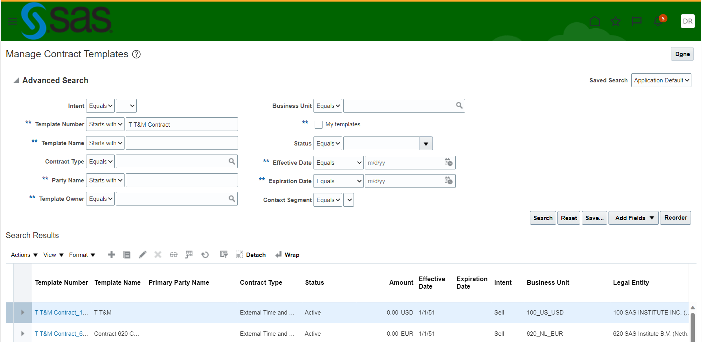

1. Highlight template row to be used > Click on Actions and then select “Create Contract from Template”

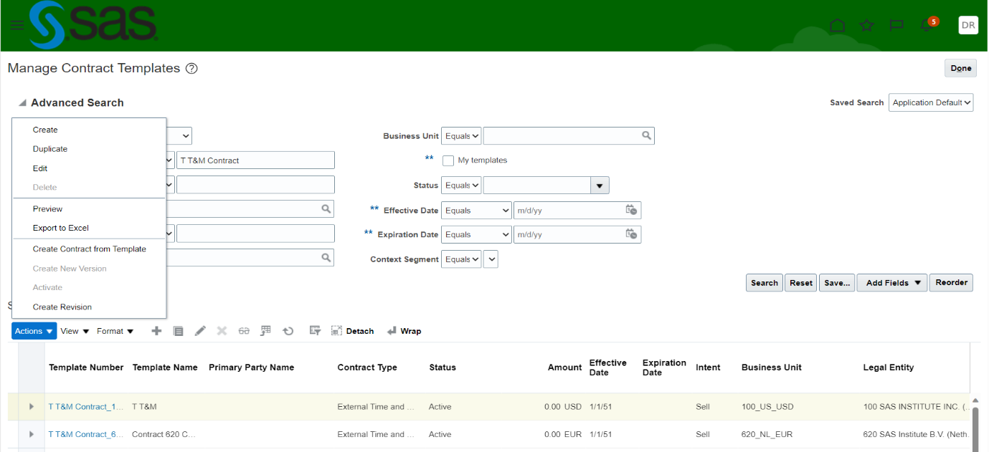

1. Enter the required details in the dialogue boxes as follows:
2. Primary Party
3. Start Date
4. End Date
5. Currency
6. The 3 boxes checked are the default selection and determine what information is carried over from the template
7. Click OK.

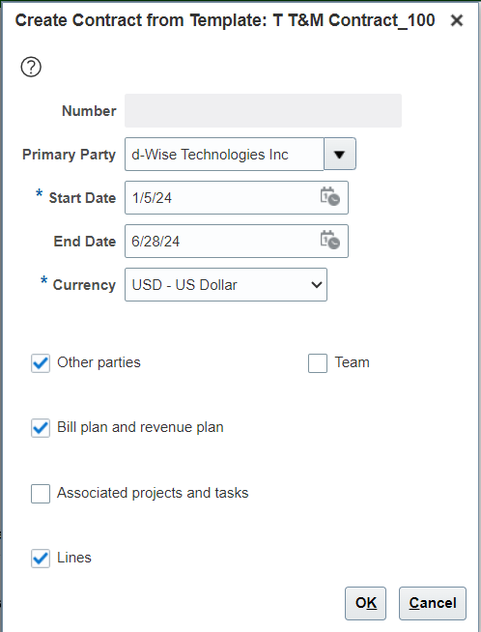

# Populate Contract Details from Project

## Overview Tab

1. Fusion automatically allocates a Contract Number.
2. Enter the following details:
3. Contract Name (Remove CON from project name)
4. Description – as mentioned in project
5. Additional Information – only if required.

## Parties Tab

1. Fusion will populate Customer and Supplier information.
2. Add the following details:
3. Bill-To Account Number
4. Bill-To Site
5. Ship-To Account Number (same as Bill-To Account Number)
6. Ship-To Site

## Billing Tab

1. Enter the following details:
2. Contract Organization as per fusion project overview (Eg: 4571 CNS consulting services)

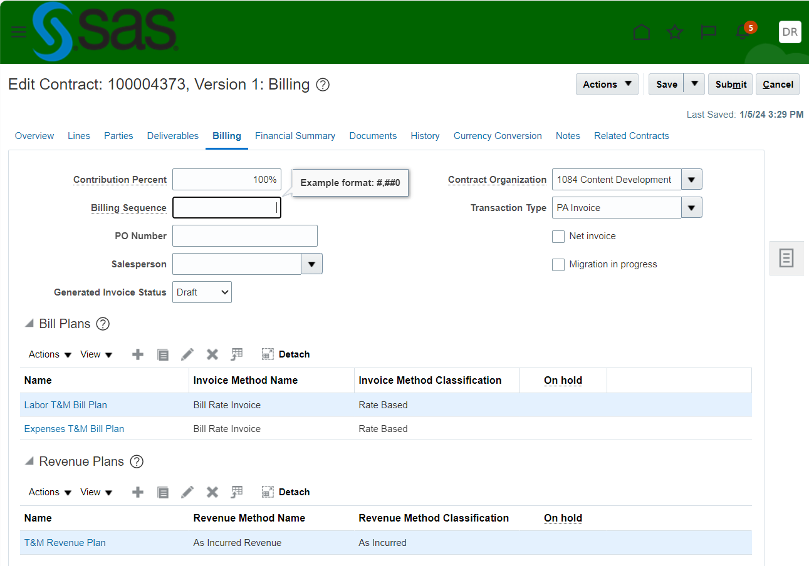

### Labor Bill Plan

1. Select Labor T&M Bill Plan (Rate Based)/Labor FP Bill Plan (Amount Based)



### General Information

1. Enter the following details:
2. Bill-To Account Number
3. Bill-To Contact
4. Bill-To Site
5. Payment Terms

### Schedules and Overrides (For TM only)

1. Check the auto populated fields are correct.
2. Under ‘Schedules and Overrides’ tab, enter contract billing title override by SR: Job Title in the ‘Job Title Overrides’ section.
3. Billing Title Override = should match verbiage in the customer contract. If no specific title is given, use “SAS Consultant”.

### Project Task Rate Overrides (For TM only)

1. Navigate to Project Task Rate Overrides tab in the labor bill plan.
2. Add lines for each Planning Role and associated rate as defined in the DPM making sure rates match contract.
3. In ‘Job’ Column, search ‘PR:’ for the list of planning roles available

1. Enter rate, Currency and From Date
2. The ‘From Date’ defaults to today’s date – this needs to be changed to match your contract start date’s month first day. The ‘To Date’ can stay blank.

### Expenses Bill Plan (If applicable)

1. Select Expenses T&M Bill Plan (Rate Based)/For FP Contracts select Expenses FPE Bill Plan (Rate Based).

### Expenses – General Information

1. Enter the following details:
2. Bill-To Account Number
3. Bill-To Contact
4. Bill-To Site
5. Payment Terms

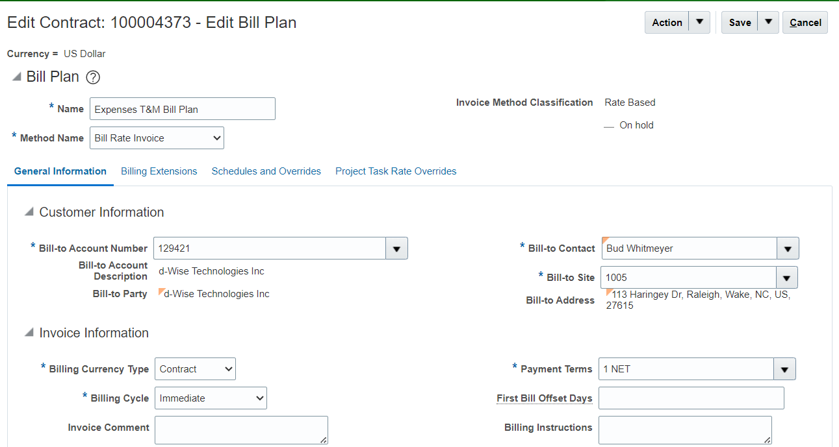

### Revenue Plan

1. Check the auto populated fields are correct.
2. Undertake the above for Labor T&M (As Incurred) and then Expenses T&M (As Incurred) / for FP Contracts – Labor FP (Percent Spent) and then Expenses FPE (As Incurred).
3. Click on Save and Close.

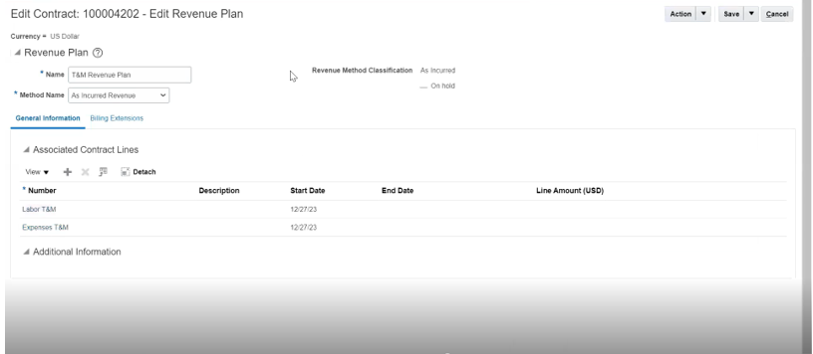

### Entering Contractor Overrides (For TM only)

1. Use + to add new line.
2. The ‘Subcontractor Hours’ expenditure type is used to enter the subcontractor override. Because of this, the project needs to be associated with the contract line so that the project, task and expenditure type can be selected on the override section.
3. Select Project Number/Name and Task Number/Name from dropdown.
4. Select Subcontractor Hours for the Expenditure Type.
5. Enter Rate, Currency and From Date.

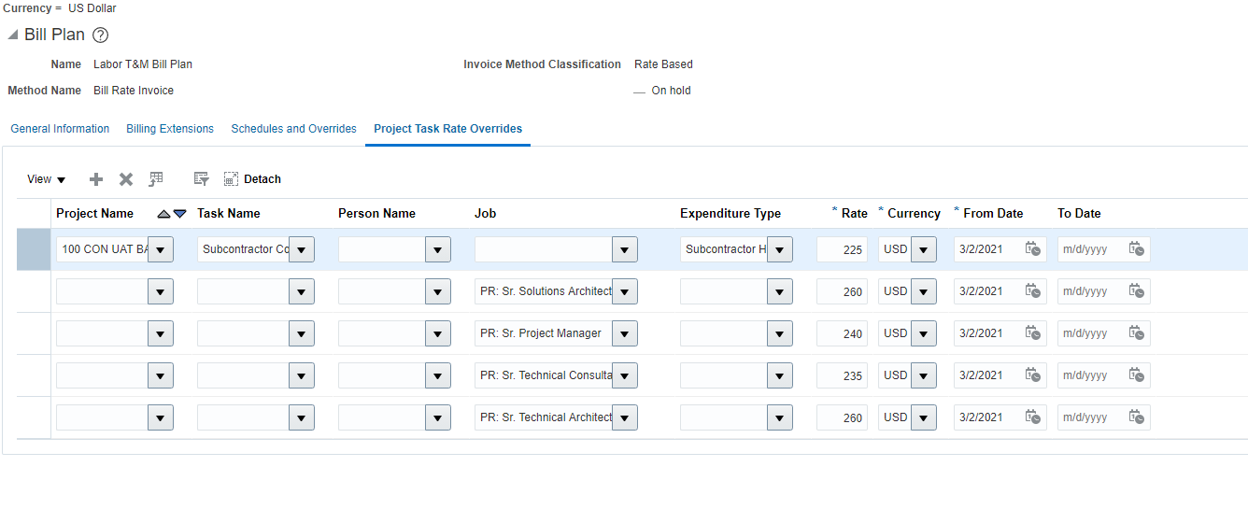

### Contingent Worker overrides (For TM only)

1. Contingent worker overrides entered like SAS employees.

### Nonregular Rates (For TM only)

1. If the contract has regular and nonregular hours (i.e. overtime) an additional line will be needed for the planning role. The expenditure type will need to be defined as Labor – Emp: Nonregular

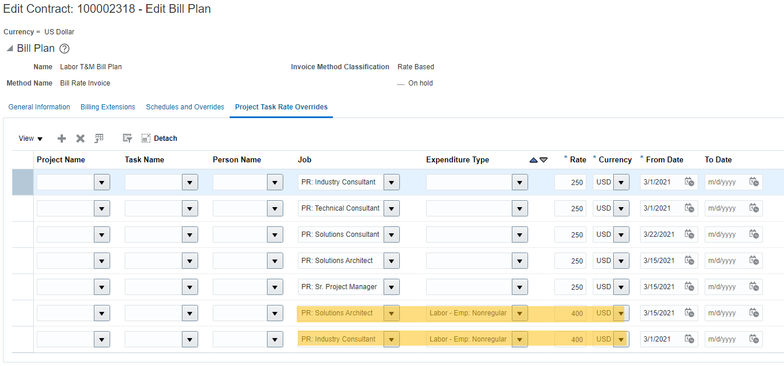

## Lines Tab – Labor

1. Select Labor T&M/Labor FP

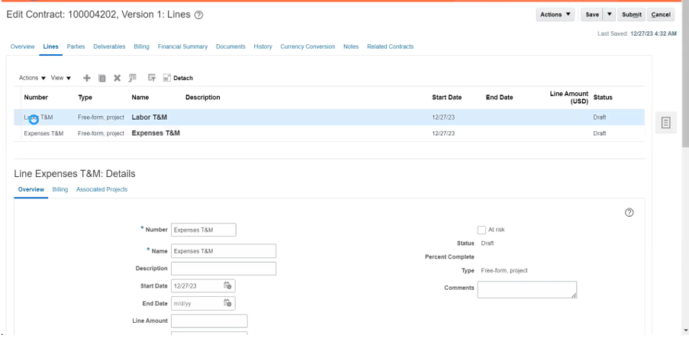

### Overview

1. Enter the following details:
2. Line Amount
3. Ship-To Account Number
4. Ship-To Site
5. Additional Information if required.

### Billing

1. Enter the following details:
2. Bill Plan – defaults to contract template.
3. Revenue Plan – defaults, change if needed.
4. PO Number – if applicable.
5. Hard Limit – mandatory.

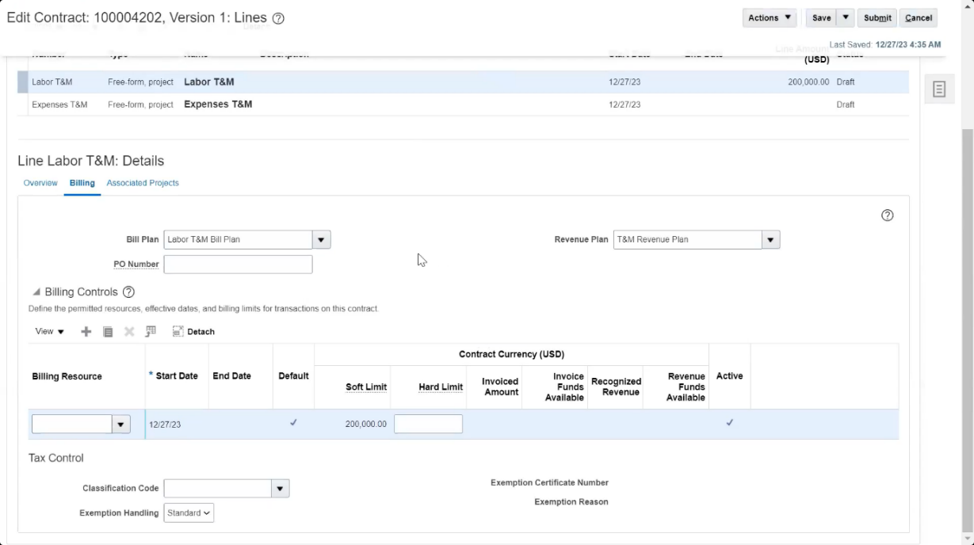

### Associated Projects

1. Click + to add a new line.
2. Enter the following details:
3. Project Name/Project Number
4. Task Name - always associate with the Top Task level e.g. Consulting Services/Task Number – always be “1”
5. Funded Amount - mandatory
6. Click on Save.

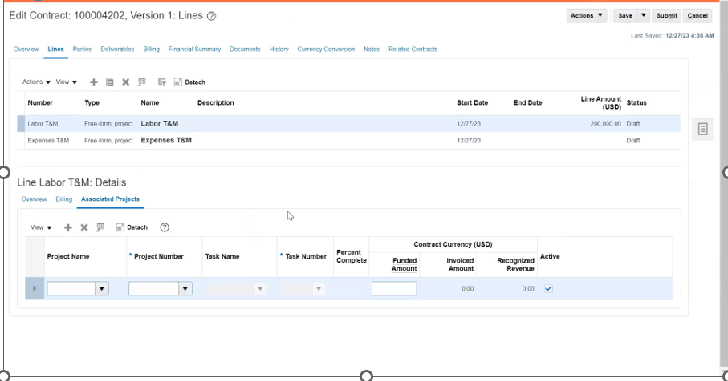

## Lines Tab – Expenses (If applicable)

1. Select Expenses T&M/Expenses FP

### Overview

1. Enter the following details:
2. Line Amount (Expense amount only)
3. Ship-To Account Number
4. Ship-To Site
5. Additional Information if required.

### Billing

1. Enter the following details:
2. Bill Plan – defaults to contract template.
3. Revenue Plan – defaults, change if needed.
4. PO Number – if applicable.
5. Hard Limit – mandatory.

### Associated Projects

1. Click + to add a new line.
2. Enter the following details:
3. Project Name/Project Number
4. Task Name - always associate with the Top Task level e.g. Consulting Services/ Task Number – always be “1”
5. Funded Amount - mandatory
6. Click on Save.

## Documents Tab

1. Add the CLM link to Order Form from Project’s documents tab
2. Change the Type from “File” to “URL”

# Validation

1. Before requesting Contract Approval, you can run a self-validation procedure in Fusion by clicking on Actions and then selecting Validate, to ensure all the mandatory fields have been completed correctly.

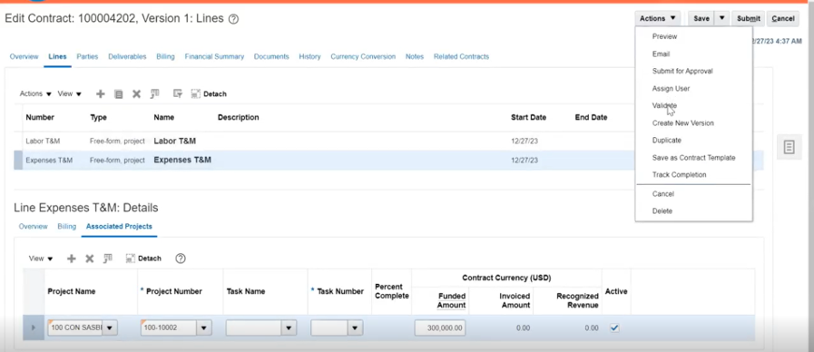

1. Clear any validation errors by following the instructions on the Validation Results screen.
2. Click on Done.

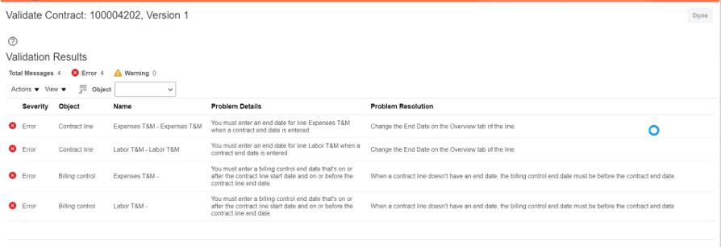

# Submit Contract for Approval

1. Click on Actions and then Submit for Approval or click on Submit.
2. Window opens - add a note to the Approver, if desired and select Submit

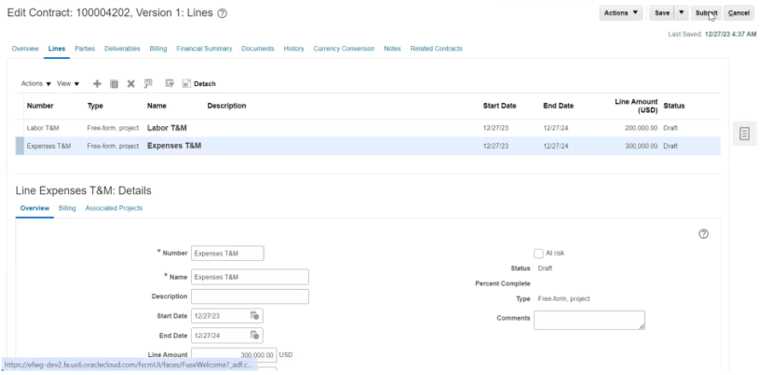

## Check Contract Approved

1. Once the contract has been approved its status will change to Active and it can be used to raise Invoices and recognize Revenue. Contract status can be found via a Search.

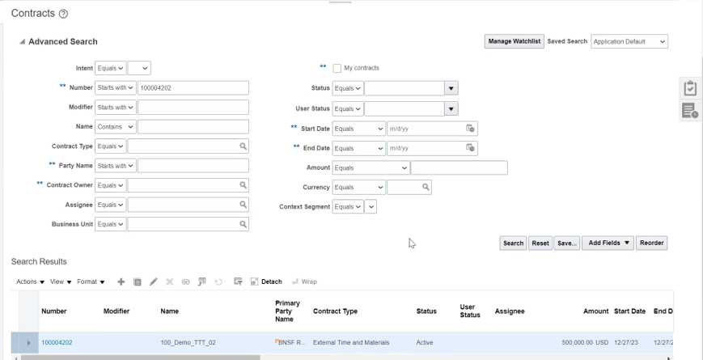

# Configuration Report (Post contract approval)

1. Go to Fusion click on tools > Reports & Analytics

1. Click on browse catalog



1. Expand shared folders.

1. Go to the path as per mentioned below click on more and marked as favorites:  
   [shared/Custom/SAS Custom/Reports/Project Manager Reports/SAS Project Contract Configurations and Specifications Report V2](https://efwg.fa.us6.oraclecloud.com/fscmUI/faces/FuseWelcome?_adf.ctrl-state=1814khjt3o_5)
2. Click on “SAS Project Contract Configurations & Specifications Rep.xdo”

1. Search the report as per Project Number, Contract Number & ensure to add correct business unit: (For e.g. Contract numbers & Project Number starting with 520 corresponds to BU Name as 520)

1. Click apply

1. Once report completed it will reflect in downloads folder

1. Upload the downloaded excel file in project > under documents tab.

# Exceptions

## Denmark (520) & Finland (600)

1. There is no change the contract name and description of project like US KT.
2. EAN number is added which is available in the CRF/Customer billing info snip in the description of fusion contract.
3. Project number is mentioned in the description of fusion contract.
4. email address [ar.nordics@sas.com](mailto:ar.nordics@sas.com) is added if the customer email address is not given but EAN number is available in the CRF/Customer billing info snip.
5. While amending fusion contract, we select the amendment date as Project start date instead of current date/end date of the project.

## Spain (640) & Portugal (670)

1. While creating the contract from template - tick associated project and tasks
2. Project number in description and in the name
3. Not to remove the CON for name (same from project).

## United Kingdom (540) & Ireland (610)

1. "SAS Consultant" to be updated in Job Title Overrides as a job role.
2. If Bill to Contact is not provided in CRF then the first name in dropdown is considered.

## Philippines (430), Singapore (435), Malaysia (436) and Thailand (437)

1. Customer Email Address field must have below email addresses copied to while drafting contract:
2. [aseandmosharedservices@wnt.sas.com](mailto:aseandmosharedservices@wnt.sas.com)
3. Respective Project Managers email address of the Fusion project.

***Process End***

Escalation Matrix

|  |  |  |  |
| --- | --- | --- | --- |
| Name | Level | Email Address | Landline/Phone Number |
| Bhaswar Banerjee | Level 1 | bhaswar.banerjee@sas.com | N/A |
| Agnieszka Bartuzi | Level 2 | agnieszka.bartuzi@sas.com | +48 22 560 45 83 |
| Beata Kienorow-Gulan | Level 2 | beata.kienorow-gulan@sas.com | +48 22 560 45 69 |